**Coding Challenge-sql**

**Name: Divya Sree Murali**

**Date : 08/11/2024**

**1.Querying Data by Using Joins and Subqueries & subtotal**

**1.1. Retrieve all customer orders along with burger names**

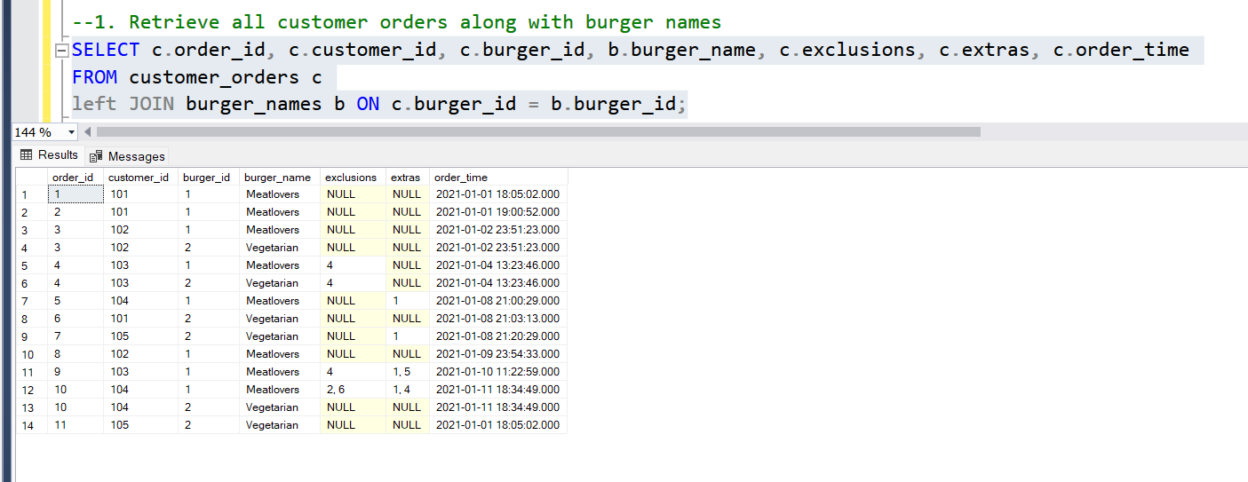

Explanation:

LEFT JOIN is useful for including all records from the primary table and any additional matching data from the secondary table

In this query, a LEFT JOIN is used to ensure that all records from the customer_orders table (aliased as c) are returned, even if there is no matching burger_id in the burger_names table (aliased as b).

**1.2. Find orders that have runner details**

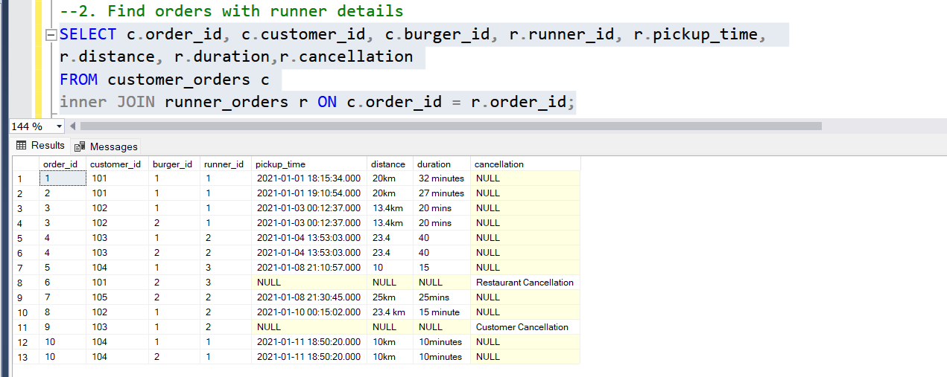

Explanation:

An INNER JOIN is used when you want to retrieve only the records that have matching entries in both tables being joined.

In the query, Only orders that have been assigned to a runner and have recorded details in runner_orders will be shown.

**1.3. Retrieve all orders,all burgers and runner details**

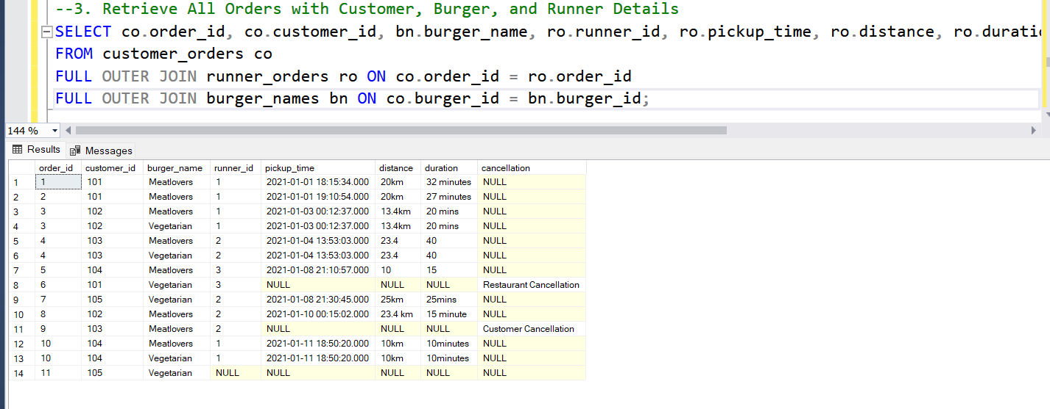

Explanation:

**FULL OUTER JOIN** is used to combine all records from both tables, including those that don't have matching entries in the other table

In the query,the **FULL OUTER JOIN** here provides a complete dataset that includes all orders, runner details, and burger names,

**1.4. Get Runner Orders with Longest Duration for each runner**

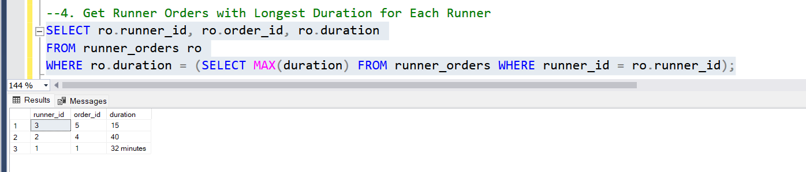

Explanation:

**Correlated Subqueries** are subqueries that reference columns from the outer query, allowing row-by-row comparisons.In the query,it compares duration of each row and return max duration

**1.5.Calculate total orders and revenue with Customer Subtotals and Grand totals**

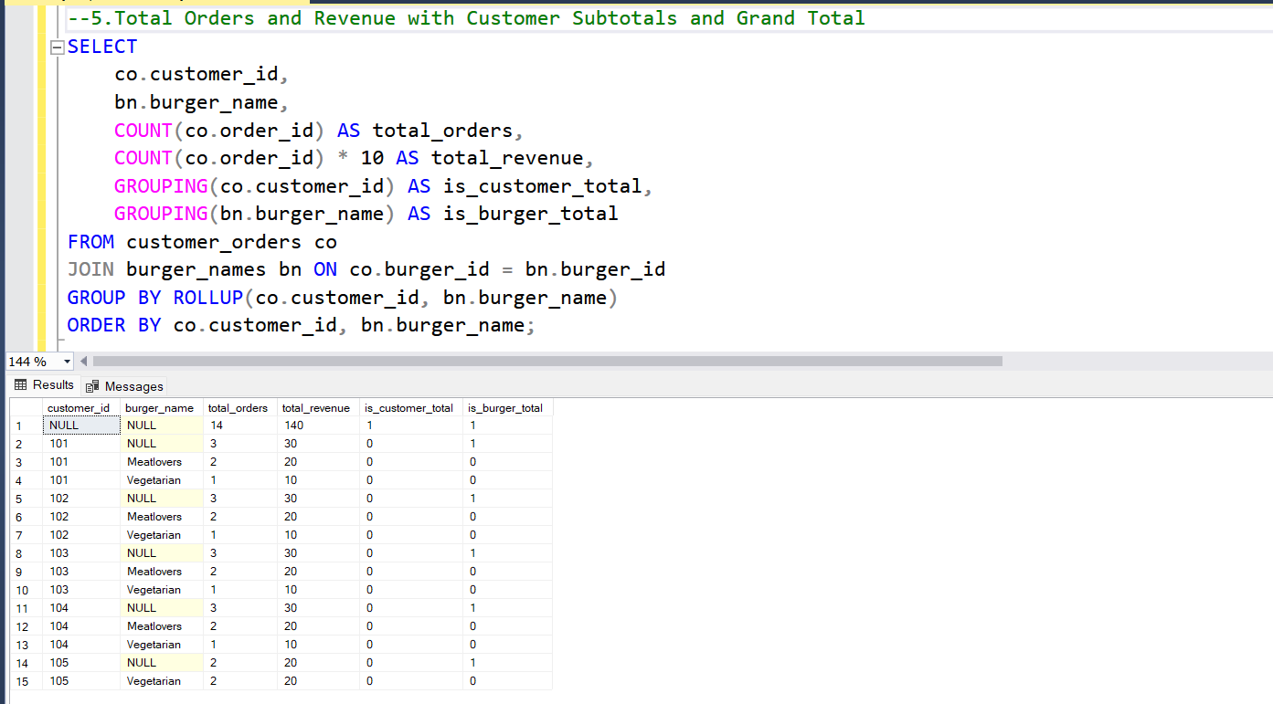

Explanation:

In this query,ROLLUP allows generating subtotals by progressively grouping on fewer columns.

Subtotals in this query make it easier to view detailed order information at multiple levels

**2.Manipulate sql data using Group by and having**

**2.1. Calculate the total number of orders each runner delivered**

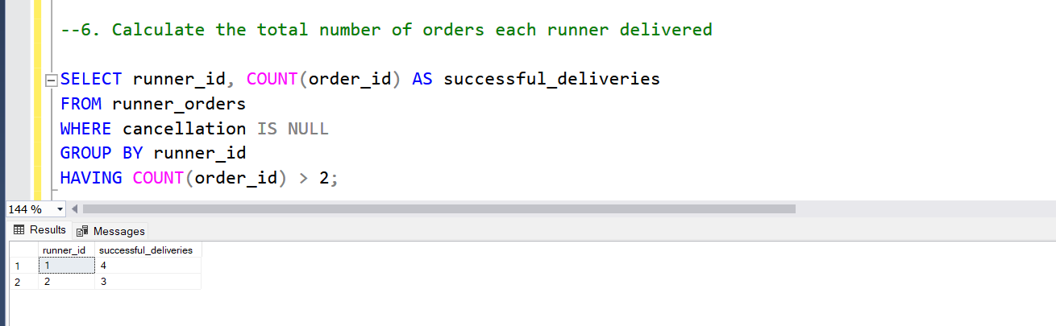

**Explanation:**

Group by is used to group rows and allows to perform calculations or aggregations on each group. Having is used to filter groups formed by the GROUP BY clause based on a condition.

**2.2. Find Customers who have ordered more than one type of burger**

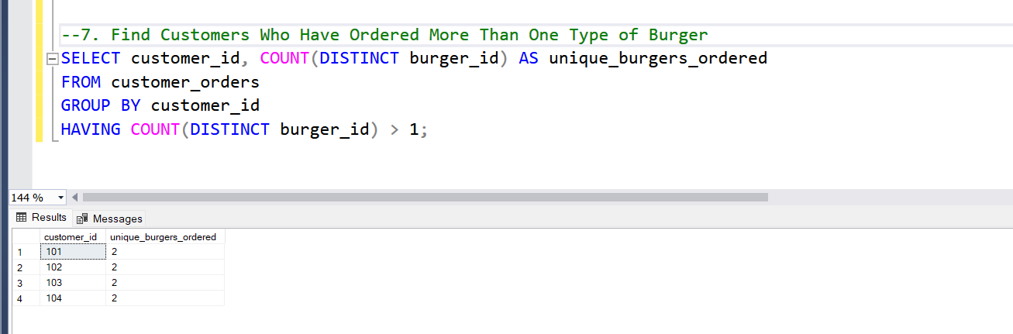

Explanation:

‘Group by’ groups the data by the customer_id column and ‘ having’ filters the groups created by the GROUP BY clause based on a condition.